

Asset Practice Answers: Science

**1. Rajan wants to re-use the water that he used for washing some fruits and vegetables. For which of these activities should he use it?**

**A.** Cooking

**B.** Drinking

**C.** Washing clothes

**D. Watering plants**

**2. Red, amber, and green are the colours in a traffic light. Sometimes we see amber alone flashing. What does this indicate?**

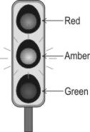

**A.** Stop completely.

**B.** Go without halting.

**C.** Go in one direction only.

**D. Stop or proceed with care.**

**3. The blindfolded student shown here was given a packet containing a few objects. He identified them as a long stick, a ball kind of thing, a soft object and a sharp object.**

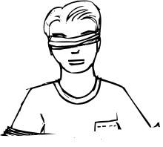

**Which of the senses did he use to identify the objects?**

**A.** Sight

**B.** Hearing

**C.** Smell

**D. Touch**

**4. Malaria is a disease that is spread by mosquitoes. Mosquitoes lay eggs in stagnant water. Which of the following methods would help to control the number of mosquitoes?**

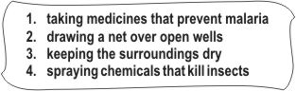

**A.** Only 1

**B.** Only 2 and 3

**C.** 1, 2 and 3

**D. 2, 3 and 4**

**5. Kumar was eating tomatoes, green beans and cucumbers. Which part of the plant was he eating?**

**A.** Roots **B.** Stems **C.** Leaves **D. Fruits**

**6. You are given four bags for your shopping. Which of these bags is bad for the environment?**

**A.** Leather bag

**B. Plastic bag**

**C.** Jute bag

**D.** Cloth bag

**7. Which of these would be the time taken by the Earth to turn once on its own axis?**

**A. A day**

**B.** A week **C.** A month

**D.** A year

**8. Kevin falls down in the playground and scratches his knee badly. He needs to do some things to treat the wound. Which of the following should he do FIRST to treat it properly?**

**A.** Apply medicine over the area.

**B.** Put a bandage to cover the wound.

**C. Wash the area gently with clean warm water.**

**D.** Rub salt over the area to protect it from germs.

**9. Binit saw a man blowing bubbles using a loop and some soap-water. This is how the loop looked.**

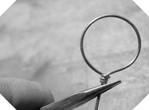

**It was made of a material that could be bent and would remain in this shape after being tied up. Which of the following objects can be used to make such a loop?**

**A.** A chalk stick

**B.** A cotton string

**C. A plastic straw**

**D.** A wooden pencil

**10. Samir looked out of the glass window of a train in the afternoon. He could see a man standing outside on a bridge. He could see everything else that was on the other side of the glass window too.**

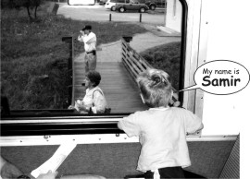

**Which other object allows things on the other side to be seen through it, like the glass window? A.** A bright torch

**B.** A clean mirror

**C.** A polished plate

**D. A pair of spectacles**

**11. When we breathe in air, our lungs swell up and grow bigger in size. When we breathe out air, our lungs return to their original size. To allow this to happen, the lungs should be .**

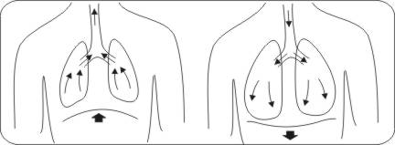

**A.** stiff and hard

**B.** made up of bones

**C. spongy and elastic**

**D.** shaped like a bean

**12. If Razia was blindfolded, which sense organ would be necessary to find out whether a substance is warm or cool?**

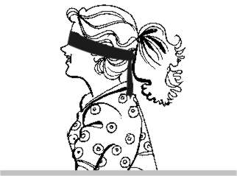

**A. Skin**

B. Ears

C. Nose

D. Eyes



**Science**

1. D: The water used for cleaning fruits and vegetables would have become dirty because of the dirt on the vegetables and fruits. So, it cannot be used for cooking or any other purpose which requires clean water. However, it can be used to water plants and the plants can then use that water to grow.

2. D: When the traffic light is working, amber colour is an indication to start the vehicles and be ready to go as the green light is about to turn on. Sometimes when only the amber light is on, it indicates that there are fewer vehicles passing by and so no need to stop at the signal but stop or go with care. It does not mean that we should not halt and look if other vehicles are coming.

3. D: Since the student was blindfolded, he could not have used his sense of sight to identify the objects. Sense of hearing and smell cannot be used to identify the objects given. You can touch the objects and say whether they are hard or soft, sharp or blunt, about their shape etc. So the student would have used his sense of touch to identify the objects.

4. D: One way to control the number of mosquitoes is to prevent the increase in number of its eggs. Mosquitoes lay eggs in stagnant water. So if we keep the surrounding dry, mosquitoes won't find place to lay eggs easily. Drawing net over open wells will also help in this. Chemicals can be used to kill mosquitoes. But taking medicines to prevent malaria will not help in controlling the number of mosquitoes. They will grow in number as long as they have places where they can lay eggs and those eggs mature.

5. D: Tomatoes, green beans and cucumbers are all fruits of the respective plants. They are not the stem of the plants that we eat. One way to identify a fruit is to check if it has seeds in it or not. Most of the fruits will have seeds in them.

6. B: Try putting a piece of leather, a piece of plastic, a piece of jute and a piece of cloth in a pit in the soil for more than 6 months. After 6 months or so, you will find that the plastic bag would have changed the least. When plastic bags are used, they cause a lot of waste that remains unchanged and causes harm to the environment. Jute is a natural fibre that we get from plants. It is not bad for the environment. Thus, option B is the only correct answer.

7. A: The Earth moves around the Sun and this movement is called revolution of Earth around the Sun. It takes a year to complete one revolution around the Sun. The Earth also rotates on its axis. It takes one day to complete one rotation.

8. C: Kevin has hurt his knee as he fell down on the playground. There are many germs along with the dirt on the playground and so the first step to treat the wound is to clean the wound with warm water so that all the dirt gets washed off. Bandage can be used to cover it after the dirt has been removed.

9. C: A chalk stick or a wooden pencil will break if you try bending it into a loop like this. A cotton string can be bent into a loop, but it will not remain in this shape after being tied up. It will hang loose. Hence, option B is incorrect. A plastic straw can be bent into this shape and will stay like this even after being tied up. Hence, option C is the only correct answer.

10. D: Try taking a small mirror and hold it near your face. Now try and see what is behind the mirror without moving your head or the mirror. You will not be able to see what is behind the mirror because you cannot look THROUGH the mirror. Glass and water are some things through which you can look easily. Spectacles are made using glass, so you can see through it. Hence, option B is incorrect and option D is correct.

11. C: If the lungs need to take in air and give out air, they need to change their shape. So, they must be soft and elastic like rubber. If air needs to fill in them, they should also have empty spaces, like holes in them. This means they should be spongy. Thus, option C is correct. A bean shape is not necessary for lungs to function properly. Hence, option D is incorrect.

12. A: If Razia is blindfolded as shown, she cannot use her eyes to decide whether something is warm or cool. She will have to use her skin and touch the substance. You cannot hear or smell whether something is warm or cool. Hence, option A is the only correct answer.